Loudness and Sound X-Word # 2
Name ______________ Grade ____
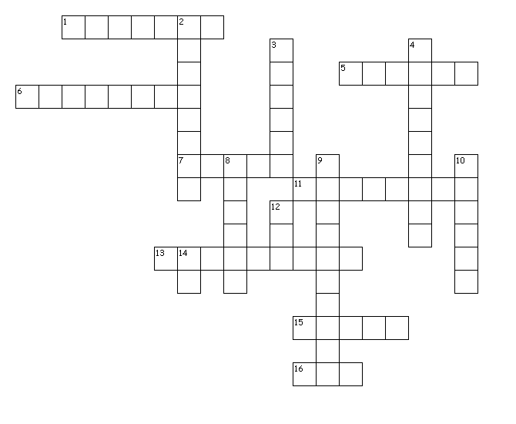
Down
2. Describes what you hear.
3. One of 3 types of mediums.
4. Pitch depends on this wave property.
8. In general, the greater the energy used to make a sound, the _______ the sound.
9. Hearing damage begins to occur at this level.
10. The material through which a wave travels.
12. One of 3 types of mediums.
14. Is there sound in space?

Across
1. The loudness of different sounds is
5. One of two factors that determines loudness.
6. using a unit called the ______.
7. One of 3 types of mediums.
11. One of two factors that determines loudness.
13. The amount of energy a sound wave carries per second through a unit area.
15. How high or low the sound is.
16. Can you break glass with your voice?

