Scientific Method Experiment Project

Goal: To create an experiment that will help you become familiar with the scientific method.

Step 1 – We will review the scientific method. Step 2 – Meet with your partner to work out ideas for experiment. Step 3 – Conduct the experiment with your partner. Step 4 – Create the lab report. Step 5 – Peer edit of the lab report.

How you will be evaluated:

1. Your group meeting.
2. Your conduct during the experiment.
3. Your lab report.
4. Your partner’s opinion.

Step 2 – Meet with partner to work out ideas for experiment.

1. Must be done with things found at your house or involve almost NO COST!! 2. Experiment must be small enough to carry on bus and be conducted in the science room. 3. Nothing that needs open flame, explodes, or involves high-speed projectiles. ` 4. No experiments on animals. 5. Plant experiments take too long, forget it.



________________________________________________________________________________________________________________________________________________________________________________________________________________________________________________________________________________________________________________________________________________________________________________________________________________________________________________________________________________________________________________________________________________________________________________________________________________________________________________________________________

Partner’s Name _________________________________ Hour ____________



Plan of Action Meeting Form:

Who is your partner? ______________________________________________________ What is their phone number? ________________________________________________

What experiment will you do? Describe it. ________________________________________________________________________________________________________________________________________________________________________________________________________________________________________________________________________________________________ Does the experiment break any of the above rules? ______________________________

Below make a list of all materials you will need.

______________________________ _____________________________

______________________________ _____________________________

______________________________ _____________________________

______________________________ _____________________________

______________________________ _____________________________

Who will bring each item? (Initial next to them)

What is your hypothesis statement? If ____________________________________________________________________, then __________________________________________________________________.

What is your independent variable? _________________________________________. What is your dependant variable? ___________________________________________. What variables do you need to keep constant? ________________________________________________________________________________________________________________________________________________________________________________________________________________________ What data are you measuring? _______________________________________________ How will you measure it? __________________________________________________ What instrument do you need to measure it? ___________________________________

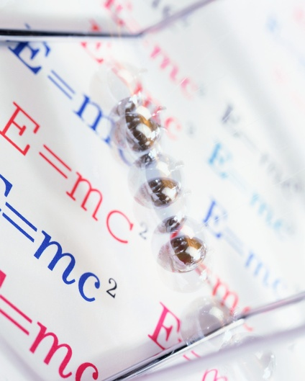

My goal is for you to practice the scientific method. I am not worried about you and your partner making a great discovery that promotes the knowledge of mankind. I don’t even care if you do the same/similar idea as someone else in the room.

Rough Ideas:

Which paper towel holds the most amount of water? Which Kleenex is strongest? What ball bounces the highest? What sponge holds the most water? Which paper airplane stays in the air the longest? Which glue is the strongest? What cleaner cleans the best?

Bad Ideas:

Dissecting an animal Making a model of the solar system



What will go into your lab report:

Page 1: Title page

Page 2: Description of your experiment - List of materials Hypothesis statement Independent Variable ( what you control or change) Dependant Variable ( what happens as a result of your change of the IV) List of things you keep constant

Page 3: On GRAPH paper, a graph of your data A data table Has a key, title, and subtitles

Page 4: What are the results of your experiment? Write as if your reader has been in a box all their life and has no clue about anything. Start off with, “In conclusion, the following was determined…………….”

Scoring Guide for Scientific Method Experiment

Name ___________________________________ Hour ______________

|  |  |  |  |  |  |  |
| --- | --- | --- | --- | --- | --- | --- |
|  | Excellent | Good | Average | Missing  Something | Not there at all!!!!! | Points |
| Partners worked well together. Stayed on task. Made effective use of class time | 10 | 8 | 7 | 6 | 0 |  |
| Partners completed plan of action. | 10 | 8 | 7 | 6 | 0 |  |
| Lab paper contains TITLE, names, hour, creative, neat, CREATIVE. | 4 | 3 | 2 | 1 | 0 |  |
| Experiment is described | 4 | 3 | 2 | 1 | 0 |  |
| Materials are listed | 4 | 3 | 2 | 1 | 0 |  |
| Hypothesis statement | 4 | 3 | 2 | 1 | 0 |  |
| IV listed | 4 | 3 | 2 | 1 | 0 |  |
| DV listed | 4 | 3 | 2 | 1 | 0 |  |
| List of constants | 4 | 3 | 2 | 1 | 0 |  |
| Graph – Has a key, title, subtitles, accurately numbered, neat, ruler used for straight lines, unit of measure. | 4 | 3 | 2 | 1 | 0 |  |
| Data table – Unit of measure, neatness, square, accurate. | 4 | 3 | 2 | 1 | 0 |  |
| Conclusion.” In conclusion the following was determined…” Tells if hypothesis was correct. Explains experiment, data, and what could be done to make the experiment more accurate. | 4 | 3 | 2 | 1 | 0 |  |
| Partner Evaluation | 10 | 8 | 7 | 6 | 0 |  |
|  |  |  |  |  | Total | /70 |

Fisher 2007