Name _______________________________ Grade ______ Wave Properties X-Word # 1

17
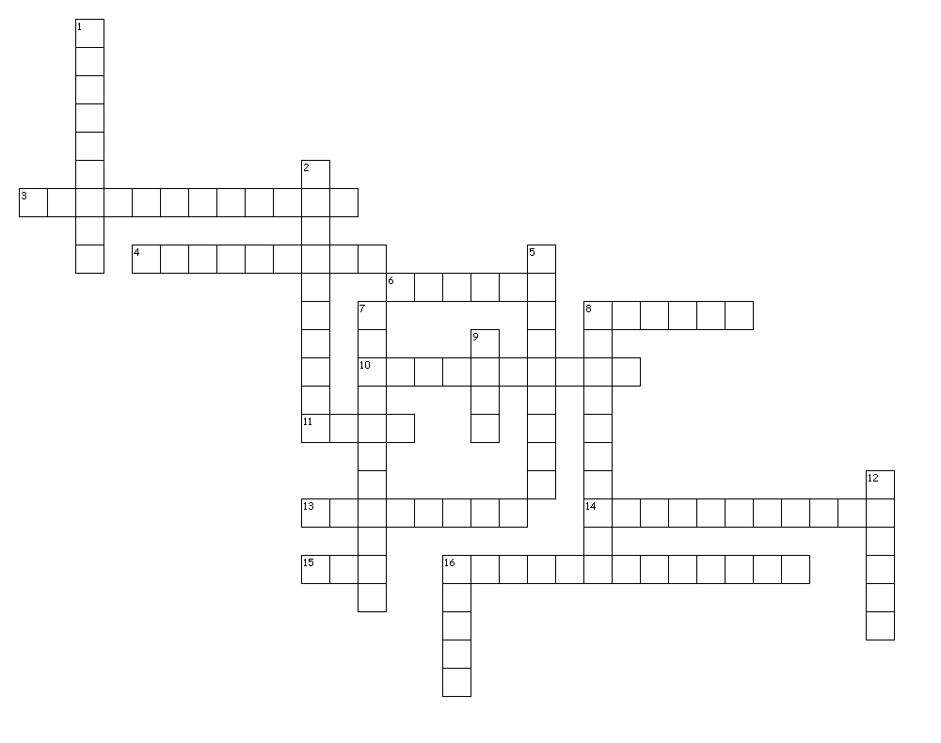
Across
1. Lowest part of a wave
4. wave in which matter in the medium to move up and down or back and forth at right angles to the wave.
6. The number of mechanical wave types.
7. Distance from resting
12. Number of waves that pass a given point in one second.
14. Crest to crest or trough to trough.
17. Frequency x wavelength.

Down
2. Far apart parts of a longitudinal wave.
3. to crest/trough
5. Another name for a compressional wave.
8. The ability to do work.
9. Close parts of a longitudinal wave.
10. Wave in which in the medium moves forward and backward in same direction as the wave.
11. Highest part of a wave.
13. The material through which a wave travels.
14. A disturbance that transfers energy from place to place.
15. These waves use matter to transfer energy.
16. Unit for frequency.

