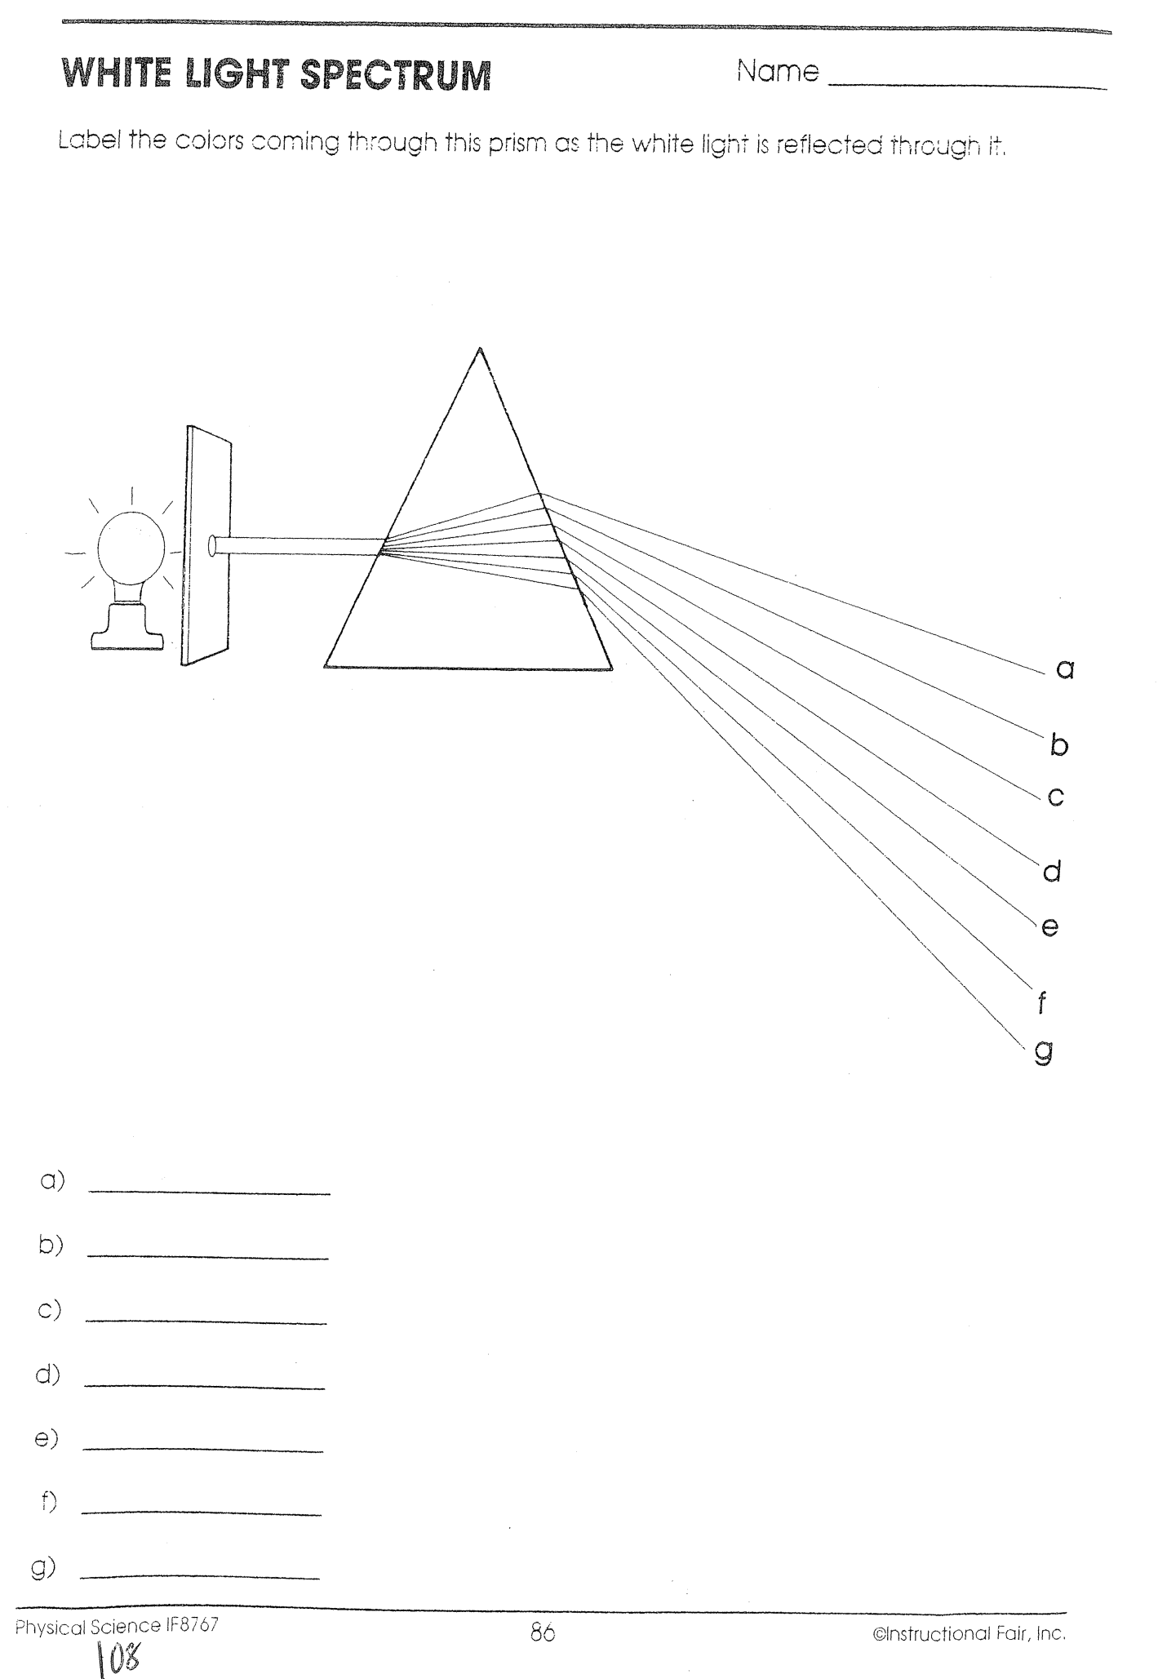

1. What happens to white light when it enters a prism?
_______________________________________________________________________________________________________________________________________________________________

2. The colors of the spectrum are always in order. What order is this?
__________________________________________________________________________________________________________

3. Why isn't there just one color produced when light enters a prism?
_______________________________________________________________________________________________________________________________________________________________

4. How is a rainbow like a prism?
_______________________________________________________________________________________________________________________________________________________________

