Adding Colors

Materials

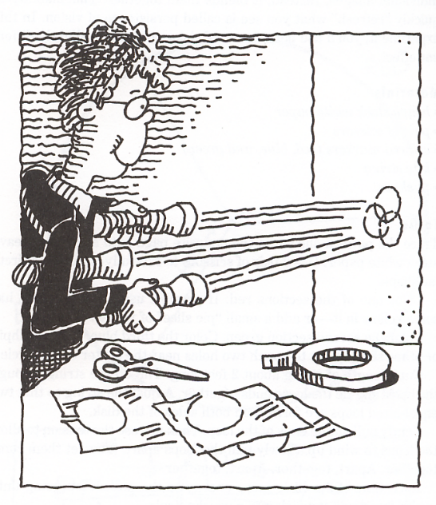
- Three flashlights covered with red, blue, and green cellophane
- White sheet of paper.

Safety Concerns: None

Procedure

1. Tape a white sheet of paper on the wall.

2. While the red remains on, aim the beam of blue so that it overlaps half the red spot.

3. Now, aim the beam of green so that all three colors ball on the same spot.

Names _____________________________________________________________

___________________________________________________________________

Absent _____________________________________________________________

Adding Colors

1. What color do you see when you shine a red beam at a white piece of paper?

___________________________________________________________________

2. What happens when you add the blue light to the red?

___________________________________________________________________

___________________________________________________________________

3. What happens when you shine all three colors together?

___________________________________________________________________

___________________________________________________________________

