Name _______________

18

Atomic Development X-Word
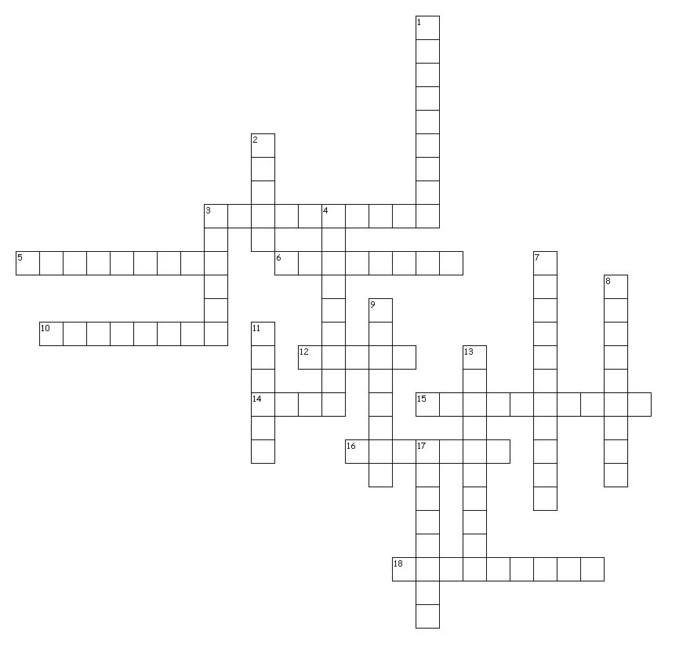

Across
3. First person to come up with the concept and term "atom".
5. Atoms of the same element are ________.
6. Discovered the nucleus.
10. Discovered the exact charge of the electron using the Oil Drop Experiment.
12. Acronym for nothing is created or destroyed, just rearranged.
14. Mendeleev arranged the periodic table by increasing atomic___________.
15. Thompson used a piece of equipment called a ___________ _______ tube.
16. Developed the modern periodic table.
18. Developed the first periodic table.

Down
1. Atoms of different elements combine in whole number ratios to form ____________.
2. All matter is made of tiny, indivisible particles called ___________.
3. Developed the first atomic theory.
4. Chemical _____________ involve the rearrangement of atoms.
7. Thompsons model is commonly referred to as ___________ _________.
9. Last name of the person who discovered the electron.
11. Greek for indivisible particles.
13. Discovered the nucleus.
17. Theorized that light can behave as a particle called a photon.

