Name ______________________________________ Date ________

Interactions of Living Things X-Word
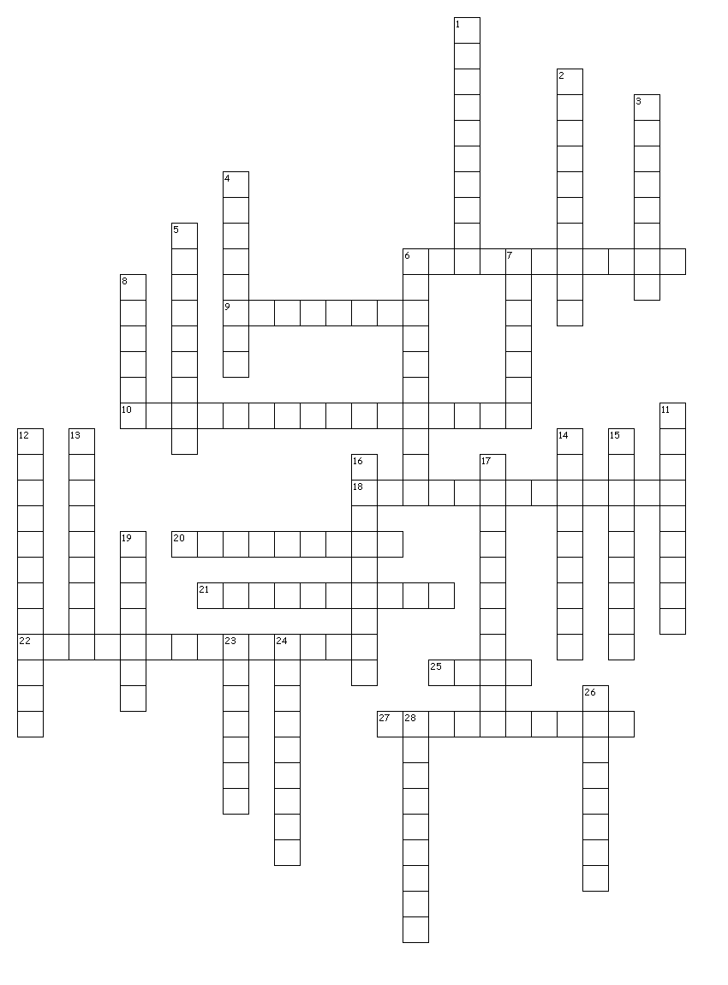
Across
2. A group of organisms of the same species.
4. The part of Earth where life exists.
5. Organism that eats only plants.
6. Diagram that shows the feeding relationship between organisms.
9. Describes the nonliving factors in the environment.
12. Pathway of energy transfer as a result of feeding patterns.
15. A living thing.
16. The layer of the atmosphere that has all of the gases.
17. Organism that eats animals.
18. A group of different populations in an ecosystem.

Down
1. Shows an ecosystem's loss of energy as it passes through the food chain.
3. Organism that produces their own food.
5. The layer of the biosphere that contains all water.
7. Organism that eats plants and animals.
8. A community of organisms and the abiotic environment of the community.
10. The layer of the atmosphere that contains all land.
11. Omnivores that eat dead plants and animals.
13. Describes living factors in the environment.
14. The study of the interactions of living organisms.

