Determining Speed X-Word
Name _____________________ Grade _____
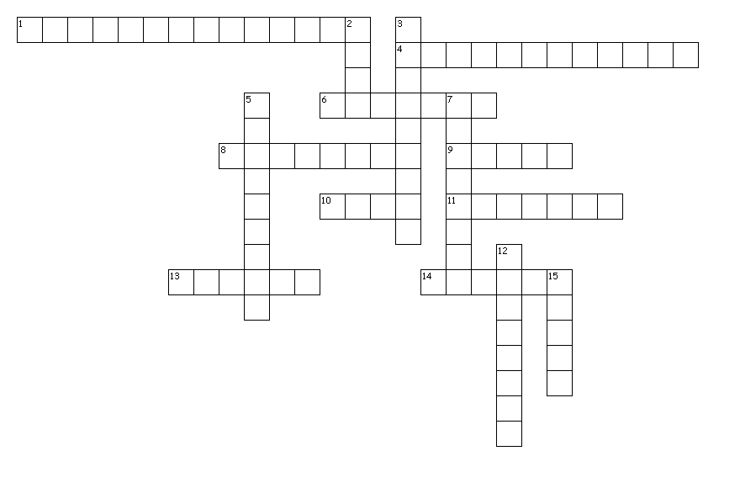
Across
1. A place or object used for comparison to determine if something is in motion.
4. Type of speed in which an object is moving at a given instant in time.
6. SI unit for time.
8. Motion is _____.
9. Equals distance/time.
10. Type of graph used to measure motion.
11. Total distance divided by total time
13. When an object is changing it's distance from another object.
14. SI unit for distance.

Down
2. Always on X axis.
3. Equals 1 thousand meters.
5. Calculate the speed of a car that travels 52 km in 2 hours. (Spell the numerical answer)
7. Always on Y axis.
12. speed with direction.
15. rise / run

You must show your work. You can use a calculator, but you must show all of the steps involved in doing the problem.
1) If Tanner rides his bike 400 m in 20 sec, how fast was he traveling?

2) Jayla arrives in science class 45 seconds after leaving Mrs. S's room, which is 6 meters away, how fast did she walk?

3) You need to get to the office which is 200 m away, and you can only walk at a rate of 1.5m/s (or you get a detention for running in the hallway). How long will it take you to get there?.

