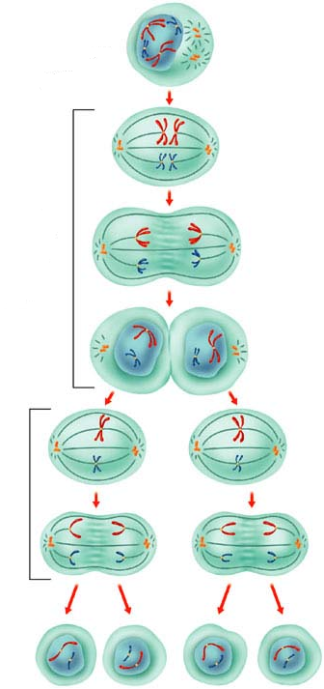
2009
Note Packet |
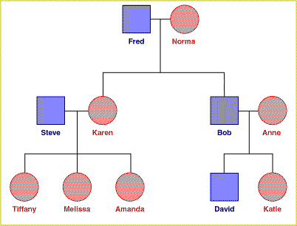
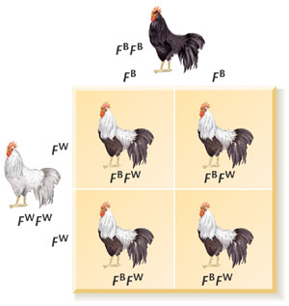
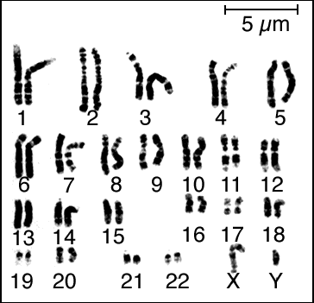
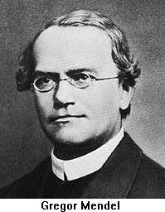
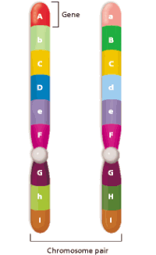
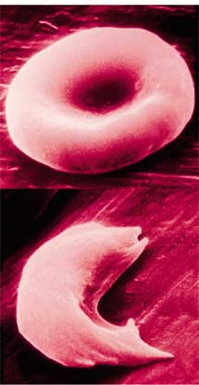
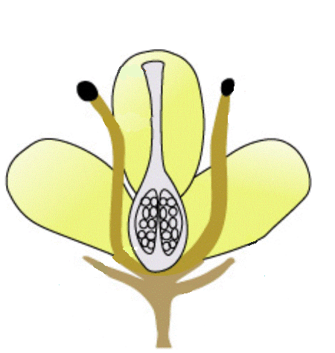
Section 1: A History

Genetics

When starting a new unit, it is best to begin at the beginning. Genetics began with…

______________________: known as the “______________ of ______________.”
- Came from a poor family, but excelled in school, so the family found a way to send him to ‘higher education.’ Gregor eventually became a ______________ (for various reasons, the educated poor generally took this route in life back in this time period).
- He was ______________ a super famous scientist. He was a high school science teacher.
- He smoked a ______________, so his fellow monks encouraged him to spend his time outside. He became the ______________ for the monastery.
- He began to notice different varieties of ______________in the garden and decided to ‘experiment’ with them.
- His experiments showed that a plant’s characteristics are passed on to ______________ in a very ______________e manner. If you know exactly what traits a plant has, you can predict what its offspring will look like. This was REVOLUTIONARY for its time.
- The scientific community ______________ his work because he “oversimplified an obviously complex mechanism.”
- He and his work were totally ______________ (meaning no one even knew his name) for the next 34 years. Three independent scientists discovered the paper Mendel wrote. These scientists all had the same results that Mendel did; too bad, he had died by this time and never knew what an impact he would have on the future.
Because of Mendel, we now have two new vocabulary words:

Heredity: the passing of ______________ from ______________ to ______________.

Genetics: the study of ______________

Part II. Prequel Flashback -- Plant Anatomy
Before we can talk about Mendel’s experiment, we need to know a little about flower anatomy...
These are the main parts of a flower:
Sepal: This is a ______________ leaf found where the ______________ and the ______________ meet. You can think of this as a left-over from when the flower was a ______________ (it was the outer layer of the bud)

Petal: This is the ______________ part of a flower.

Reproductive Parts:
Male Parts (Stamen):
Filament: This is a ______________ stalk that the anther sits upon.
Anther: This produces the ______________ of a plant.

Female Parts (Pistil):
Stigma: The Pistil is usually shaped like a ______________. If this is so, the Stigma is the ______________ at the ____________.

Style: This is the long ______________ of the vase. It ______________ the Stigma to the Ovary.
Ovary: This is where ______________occurs. The ovary will eventually develop into a _______.

A complete flower has ______________ male & female parts.

Sepal
Petal
Ovary
Anther
Filament
Style
Stigma

How A Plant Is Fertilized

______________ grains are produced in the ______________. Pollen grains contain the plant’s sperm cells. These grains are either blown about by the ______________ or moved from one flower to another by ______________.

When a pollen grain lands on a ______________ it grows a long tube that extends down to the ______________. The sperm cells move to the ovary and fertilization occurs. ______________ form inside the ovary that will eventually grow into a new plant. The ovary normally develops into a structure that will protect the seed and help it get established (a ______________).

If the pollen that fertilizes a flower came from the ______________ flower it is called ______________-Fertilization. If the pollen that fertilizes a flower comes from a ______________flower it is called ______________-Fertilization.

A flower that would favor Cross-Fertilization:

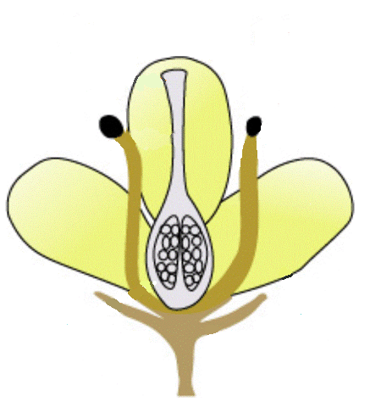
Why would this flower be most likely to cross-fertilize?

A flower that would favor Self-Fertilization:

Why would this flower be most likely to self-fertilize?

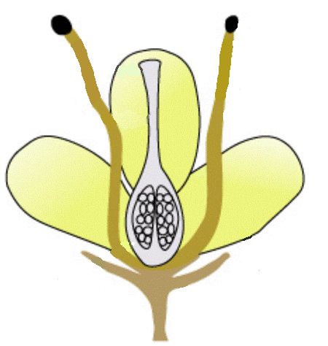

Mendel’s Pea Plants were the type of flower that normally self-fertilize. For his experiment, he wanted to control what pollen fertilized a particular flower.

Part III. Back to the Experiment
The first thing Mendel wanted to discover was why some of the pea plants were ______________ and some were ______________.

- First he Self-Pollinated ______________ plants and noticed that he always got ______________ plants as a result. At the same time he Self-Pollinated ______________ plants and similarly always got ______________ plants as a result.
  - He called these plants “______________” because they ______________ produced the ______________ type of offspring.

    - Next, he decided to cross-pollinate ______________ traits. He crossed a short purebred with a tall purebred. He called these the Parents (P).

      - What do you think happened?
Short x Tall =

- Mendel named the next generation of pea plants the First ______________ (“son” in Latin) or F₁.
  - The F₁ generation of pea plants were ______________!

    - This, of course, made him wonder where the “shortness” went. He crossed ______________ plants from his F₁ generation to make an ______________ generation.

      - The ______________ trait came back in the F₂ generation! He produced 3 ______________ plants for every 1 ______________ one. This ratio can be written:
____________________________

______________ time he performed this experiment the short trait always disappeared in the F₁ generation, but reappeared in the F₂ in the same ratio! There was definitely something going on here, and it was not random.
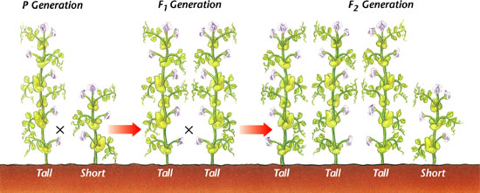

Mendel decided to test other traits that he noticed in his pea plants. Mendel tested ______________ traits in all and always got the ______________ results!

Mendel eventually developed an explanation for his results.
- He said that there must be some ______________ of a parent plant that gets passed on to the offspring and ______________ what the offspring looks like. He called this a ______________.
- He decided that different ______________ of one gene must exist and called them ______________. (in this case there was Tall & Short)
- He hypothesized that ______________ parents donate their version of the gene, but that one type of allele can ______________ the other. He named these different versions of alleles ______________ & ______________.

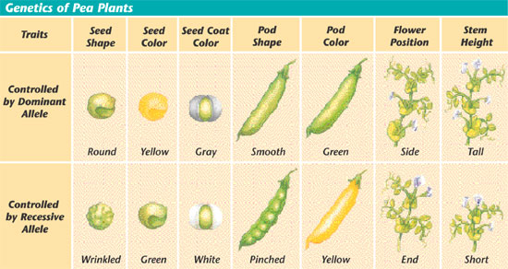

- Mendel developed a technique to ______________ what the offspring will be. It is called a ____________ ____________.

He coded the genes & alleles using the following pattern:
He assigned the gene a letter. The dominant version got the ______________version of the letter. The recessive version uses the ______________version.
Example. T = ______ t = ______________

T
T
t
t
P₁
Tt | Tt
Tt | Tt
1st Cross

____ = Purebred pea plant for the Tall Allele. Since both alleles are the same this type of plant is called ______________.

____= Purebred pea plant for the short allele. This is also ______________.

TT x tt = Tt + Tt + Tt + Tt

______________ of the offspring will have one of each allele!

- If an organism has ______________ different ______________ it is called ______________, or ______________.

The next cross Mendel did was between two of the F₁ offspring.
T
t
T
t
F₁
2nd Cross
TT | Tt
Tt | tt

The F₂ generation looks a lot different from the F₁.

You can describe an organism by its Genotype or Phenotype.
- ______________: The actual combination of Alleles (genetic
makeup)
- ______________: How the organism __________ (or ‘ph’eels)

The F₂ generation has 3 different Genotypes:
TT (25%) Tt (50%) tt (25%)

The F₂ generation has 2 different Phenotypes:
Tall (75%) short (25%) This is a Ratio of 3:1

Gregor Mendel did many more crosses based on his ideas, including crosses dealing with ______________ traits. For example, Tall, Yellow Pods, Wrinkled seeds X Short, green pods, round seeds. The Punnett squares get bigger, but the same basic theories on how the genes would move held true. The ratios he would predict would occur.
Mendel did get VERY lucky though in his choice of the pea plant. Each one of these traits is found on a different chromosome, so none of them were linked to each other. If they had been, his data would
have been confusing.

Section 2: Probability
______________: the likelihood that a specific ______________ will ______________.

There are 2 kinds of probability: ______________ & ______________

Let’s talk about a quarter:
- What are the chances that it will be heads? _________ or ______
- What are the chances that it will be tails? _________ or _______
- What are the chances that it will land building side up? ____ or __
- What are the chances that it will be heads or tails? _________ or _________
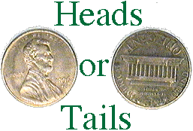

Remember, that is just a _________ and is not absolute:
Flip a coin 10 times, what is the predicted ratio? _________ _________
- Did this happen?

But, the _________ times you do it, the closer you should come to the mathematical probability. In science, the _________ trials the _________! But, in reality, we don’t have the money or the time.

Next question:
- If a quarter has landed heads 9 times in a row, what are the chances that it will land tails on the 10th throw? 50%

  - Each flip is _________ of the ones before it!
New Scenario:
    - I have a bag that contains _________ MARBLES , ______________ marbles, & ______________ marbles.

What are the chances that:
      - I will pull a ______________ from the bag?
3
10
Green Marbles = 3
= 30% or .3
Total Marbles = 10
      - I will pull a Red Marble from the bag? . ______________
      - I will pull a Purple Marble from the bag? ______________
      - I will pull a Blue marble from the bag? ______________
      - I will pull a Red or Green marble from the bag? ______________

Okay, so how does this Genetics stuff actually work in cells?
During Mitosis all of the ______________ condenses into ______________ .
Every specie on Earth has a certain Number of Chromosomes:

Humans: _____ pairs =
______ Chromosomes
______: 78 Chromosomes
Silkworms: _____ Chromosomes
Onion: 16 Chromosomes
Fruit Fly: 8 Chromosomes
E. Coli bacteria: _____ Chromosome
________: 32 Chromosomes

A Karyotype is a picture of all an organisms Chromosomes lined up in pairs.

The number of Chromosomes you have has ______________ to do with how ______________ you are.

When your body packs the chromatin into chromosomes, each section of DNA codes for a different gene. These ___________ can be seen in your chromosomes. The _________ area of each pairing chromosome represents the ________ gene, but could be different _________ because one came from your ________ while the other came from your father!

T

t

Y

y
r
r

If these were two chromosomes from one of Mendel’s pea plants…

What would the genotype be for height?

What would the phenotype be for height?

What would phenotype be for seed color?

What would the genotype be for seed shape?

What would the phenotype be for seed shape?

You have two types of cells in your body
______________ Cells: any body cell that has an entire set of Chromosomes.
______________ Cells: a cell used in fertilization that has ½ the normal number of chromosomes. (sperm & egg)
Sex cells are created through a process known as ______________.
______________ is a type of ______________ that creates cells with ½ the original number of chromosomes.

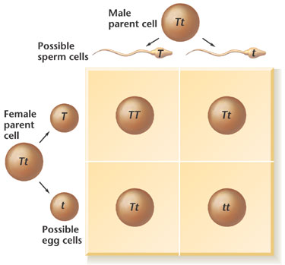
When two sex cells come together (sperm + egg) a process happens called ______________.

During fertilization, the chromosomes in ______ sex cell combine to create a ______ ______________ set of chromosomes. This one cell then goes through a complex series of __________ divisions (guided by the ________) until it creates a new complete organism that ________ traits from ________ parents.

Look familiar?

So, to Recap:
- ______________ is found in the ______________ and is made from ______ base pairs.
- Specific sequences of DNA are called ______________.
- Chromatin (DNA) condenses into Chromosomes before Meiosis.
- Each Chromosome contains 1000’s of genes.
- These chromosomes are split and recombined to create a new organism.
- This new organism is made of up ½ of each parent’s genes.
  - So, a particular gene could be traced back through a family tree.
  - Or, a Doctor could give you the probability of you passing certain traits to your offspring.

Section 3: Mutations

Okay, first, to set some facts straight (and kill some fairy tales):
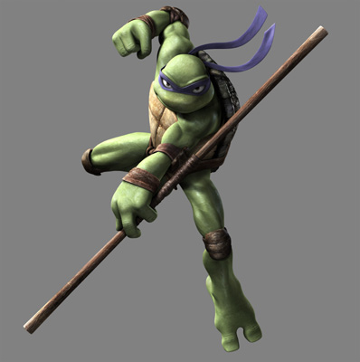
- Mutations ___________caused by things called ______________.
- Mutations will not turn pets into Teanage Mutant Ninja Turtles.
- Nor will mutations create people will _____________ for ______ like in X-MEN.

- A _____________ is any ____________ that occurs in a __________ or a _______________.

If a mutation were to occur to a __________ something like the following could happen:

A nitrogen base could be deleted.
ACGTGCAGTA ACGGCAGTA
What was deleted? ________________

A base could be inserted.
ACGTGCAGTA ACGTTGCAGTA
What was inserted? __________________

Because of the way genes are read to make proteins, these types of mutations have drastic effects. Like a taking a gear out of a clock.

Or, a base could be _____________________.
ACGTGCAGTA ACGCGCAGTA
What was switched? __________________

Part II. Effects of Mutations
A mutation can have either a ______________ , ______________ , ______________ effect.
    - This depends on what ____________ ______________ the mutation happens in and the ______________ where the organism lives.

If the mutation happens in a ______________ cell (like the sun can cause in a skin cell) then that mutation will only affect ______________ cell. If that cell were to divide, it would pass the mutation on but the effect is localized to a ______________ part of the body. This is no big deal since you are made of ______________ of cells. It is very likely that the mutation will cause the cell to ______ and the mutation will be ___________. The only problem is when the mutation causes the cell to grow uncontrollably __________.

However, if the mutation happens in one of your ______________ cells the effect will be ______________! This is the ______________ copy of ______________ that you pass on to your offspring, so ______________ cell in your offspring will carry the mutation. For example, if one of your sex cells had a mutation that affected the skin’s ability to make ______________. Your offspring might not be able to make skin color. This is called ______________. Whenever you get ______________, you will notice that the attendant covers you with a ______________ apron. One of the reasons is to keep the X-rays from causing mutations in your sex cells.

- ______________ mutations ______________ the functions of the cell or body to the point where the cell with the mutation ______________ or the offspring will ______________ form.
- Many mutations that do not cause termination will only have ______________ affects that are ______________ noticeable by themselves.
- ______________ mutations actually cause a positive, ______________ affect

So, the expression of the mutation is determined by what type of cell is mutated. But, the affect depends entirely on the environment.

If a buffalo were born with white fur, its chance of living might be different from that of a buffalo with brown fur…

- If it lived in the ______________, ______________ would be able to pick it out of the ______________. Any change that makes an organism ______________ likely to reproduce is ______________.
- If the buffalo lived in a ______________, though, the white fur would ______________ have ______________ affect on the buffalo’s chance to reproduce, so it would be ______________

Therefore, the ______________ a mutation has on an organism depends on what ______________ it happens in and what type of ______________ the organism lives.

Genetic Engineering:
The process of isolating ______________ in one organism that perform a specific ______________ and putting those genes into ______________ organism in hopes of them performing a similar action.
There are many good uses for this:
Human genes have been put into Bacteria
Scientists were able to put the human gene that makes ______________ into the DNA of a bacteria. This bacteria now makes ______________ even though it does not need it for any reason. This ______________ can be harvested and given to ______________ so that they can live.

Genes from one plant have been given to another
- Genes from plants that live in _______ areas (cacti) have been given to __________ climate plants (tomatoes) so that they might live in drier areas. This is very important to people who live in _________ areas such as parts of the Middle East or Africa.
- Genes from plants that create __________ with lots of ____________ have been added to many other plants to make them ___________ for us.
- Plants have been made able to live in lower ___________ than normal & have also been made to resist ______________ better than normal because of Genetic Engineering.

Gene Therapy
This is a very ____________ & experimental ____________ treatment where _____________ copies of genes are put into _______________. These viruses normally ______________ your cells for bad reasons, but in gene therapy they invade and ______________ ______________ genes with ______________ ones.

Part IV. Pedigrees

A ______________ is much like a Family ______________. It shows births & marriages, but most importantly, it shows who ______________ specific diseases & who ______________ of the disease are.

Pedigree I

This pedigree shows marriages & kids. Notice that ________ are __________ & ___________ are ____________.

Pedigree II

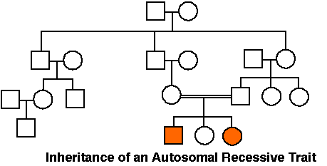

This pedigree shows __________ generations in a family. The two ______________ shapes represent members who have a ______________ genetic condition, such as Cystic Fibrosis. Note that the parents of the affected children are 1st ______________. The chances of a recessive phenotype occurring ______________ when close relatives produce offspring [inbreeding].

Pedigree III
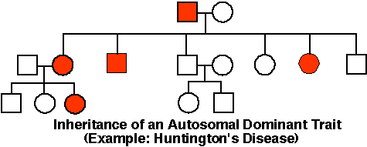

This pedigree shows ______________ generations in a family. This pedigree traces a ______________ genetic phenotype such as Huntington’s Disease.

See if you can answer the questions:
1. How many children did the first parents have? ________
2. How many were boys & how many were girls? ______________
3. How many of the 2nd generation show Huntington’s Disease?
______________
4. What is the chance of passing the disease off to offspring?
______________
5. Would you have children if you knew you had the disease?

Pedigree IV

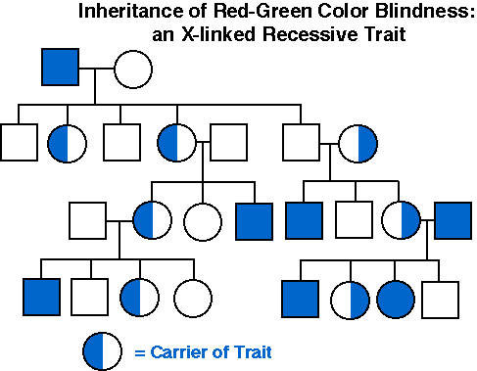

Pedigree IV from the previous page traces Color Blindness through a family.
1. How many generations are shown? ______________
2. What does the Half-colored circle mean? ______________
3. Which sex shows color blindness more than the other does? ______________
4. Do all Daughters of Males with color blindness have the allele?
______________

Pedigree V
This is the European Royal Pedigree tracing ______________ through the Royalty.

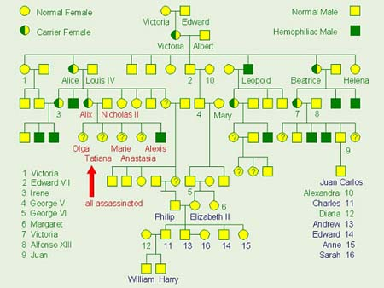

Part V. The Future
Should You Have Kids?
When people get older, (MUCH OLDER than YOU) they begin to plan starting a family. Sometimes people know about disorders or genetic traits that have shown up in their family, others have no idea.
Having a child is a very important decision and needs to be done responsibly.
People who wish to know more about their family & their children can get information a couple of different ways:
Genetic Counseling
A pair of would-be parents would go see a Genetic Counselor. The counselor would use the family history, ______________, ______________, & punnett squares to determine the couple’s chances of having a baby with specific genetic disorders.
For instance, a couple’s family has a history of Cystic Fibrosis. First the counselor would test the couples DNA to determine if either of them were carriers for the Gene.
What if the Man was a carrier, but the woman was not?
- There would be ______________ chance their children would have the disease, but there would be a ______________ chance that their child would be a ______________
What if they were both Carriers?
- They would have a ______________ chance of an ______________ child, a ______________ chance of having a ______________, or a ______________ chance of having a child with the disorder.

______________ is a process where doctors remove amniotic ______________ from a pregnant mother to see the Karyotype of a baby’s ______________. They can then look at the baby’s chromosomes.

