Name _____________________________________ Date _____

Goal 1 Double Puzzle
Find the vocabulary word for the each definition on the right side. Write it in the box on the left Copy the letters in the numbered cells to other cells with the same number. Use those numbers to fill in the joke at the bottom.

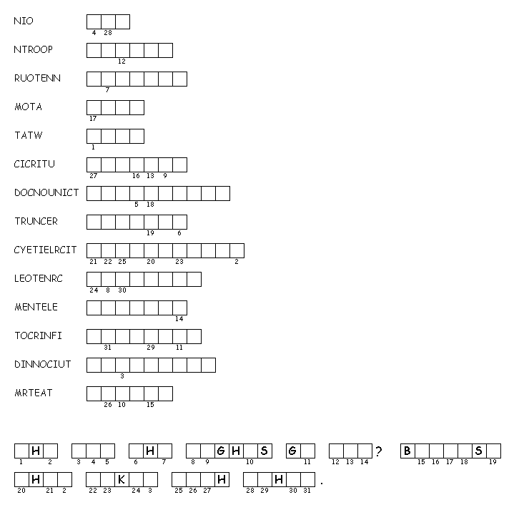

8. The flow of moving electrons in a circuit.
12. When an object becomes charged by rubbing against another object.

13.When an object is charged without touching an object.

10. The negative charge of an atom.
7. When an object is charged by touching an object.

5. The unit of power.

6. The path for the electrons to move through.

14. Anything with mass and volume
11. Makes up matter

9. The flow of electrons

3. Neutral charge of an atom

4. Smallest part of matter.

2. Positive charge of an atom.

1. An atom with a charge.

