Name__________________________________________________ Date_____________
Goal 2 Cross Word – The Moon

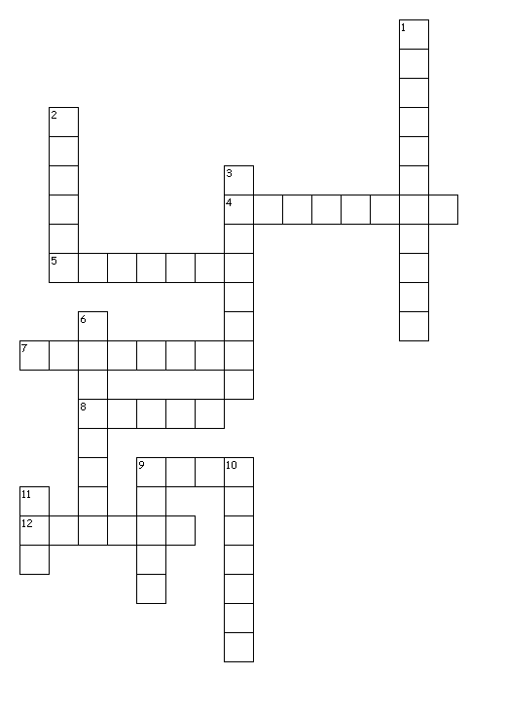

Across
4. The spinning on an axis.
5. When the moon is between 1st Quarter & Full it is called a waxing _____________.
7. This occurs when the Moon & the Sun are on opposite sides of the Earth.
8. The moon orbits around this.
9. Our planet's large natural satellite.
12. When the moon is between full & new, the visible part of the moon is decreasing.

Down
1. Rotation This is the reason we never see the dark side of the moon.
2. When the moon is between new & full, the visible part of the moon is increasing.
3. When the moon is between New & 1st Quarter it is called a waxing ____________.
6. When there is more than one full moon in a month, the second moon is called this.
9. It takes approximately 1_________ for the moon to revolve around the Earth.
10. This occurs when the moon is between the sun & the Earth.
11. A blue moon happens every ________ years on average.

