Name _______________________________ Date ____
Goal 3 X-Word
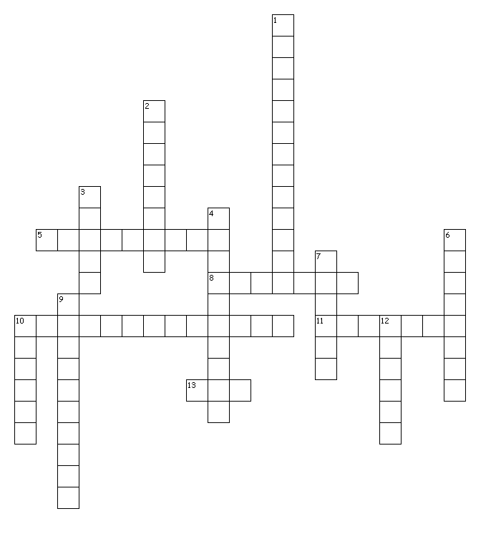

Across
5. One component that describes force.
8. Force that is applied to an object by a person or another object.
10. Fluid friction experienced by objects moving through air.
11. Magnitude of the pulling force exerted by a string, cable, chain or similar object on another object.
13. Combination of forces are called ______.

Down
1. The force that pulls objects toward each other.
2. One component that describes force.
3. A push or pull.
4. This type of force can cause an object to start moving, stop moving or changes direction.
6. This type of force does not change the object's motion.
7. The unit of measure for force.
9. The force that one surface exerts on another when the two surfaces rub together.
10. Direction and strength are represented by this.
12. Force exerted by a compressed or stretched spring upon an object that comes in contact with it.

