Name _________________________________ Date ___________

Goal 4 X-Word 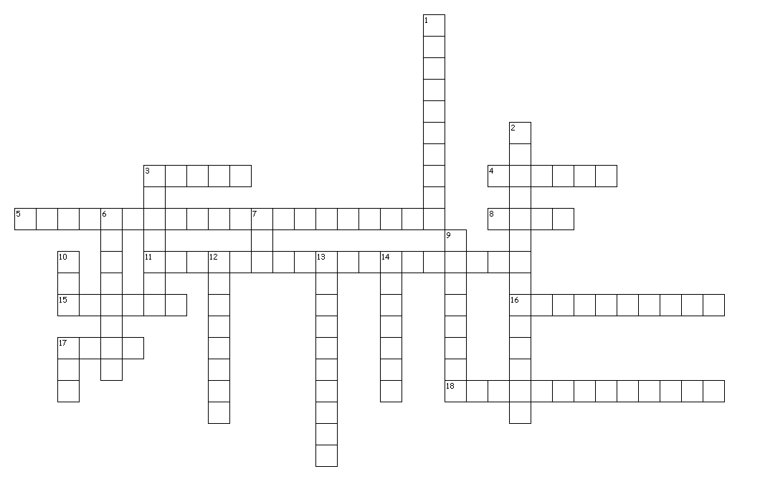

Across
3. Law that states like charges repel, or push away, and opposite charges attract.
5. An atom with a charge.
8. The negatively charged part of an atom.
10. The charges always flow in the same direction
12. The ‘electrical push’ which the cell gives to the current.
14. Continuous flow of electrons through a material.
15. One way that an object can become electrically charged.
19. Anything that has mass and takes up space.

Down
1. The charges continually shift from flowing in one direction to flowing in the reverse direction.
2. Reusable safety switch that breaks the circuit when the current gets to high.
4. The opposition to electric flow in a circuit.
6. Materials that transfer electrons easily
7. Material which electrons cannot flow easily.
9. Prevents circuits from overheating.
11. When charges are able to flow directly from the circuit into the Earth in the event of a short circuit.
12. The unit for voltage.
13. Amount of charge flowing past a point each second.
16. The unit for resistance.
17. Smallest part of an element.
18. The positively charged part of an atom.

