Name_________________________________________________ Date_______
Goal 4 – X-Word
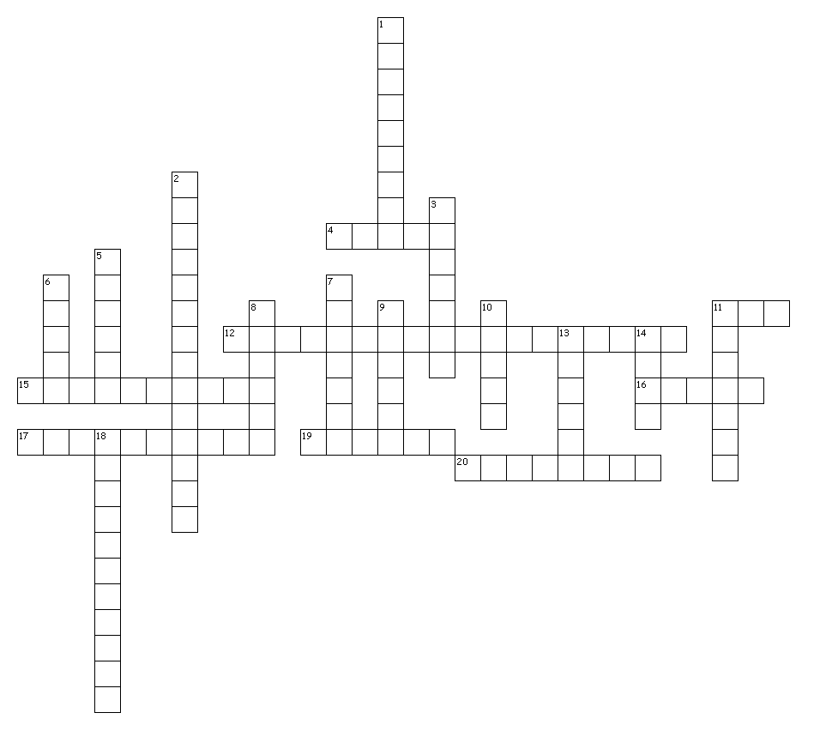

Across
4. FRESHWATER ecosystems include this.
11. How many main biomes are there?
12. ECOLOGISTS estimate that a MILLION species of insects live here.
15. One type of aquatic ecosystem.
16. FRESHWATER ecosystems include this.
17. A place of SHALLOW water, where many forms of life live.
19. IS AN AREA THAT RECEIVES LESS THAN 25 CENTIMETERS of rain a year.
20. Grasslands that are located closer to the EQUATOR are known as these.

Down
1. The DEEPEST part of the oceans.
2. An area between the HIGHEST high tide and LOWEST low tide.
3. the place where FRESH water of a river meets a SALT water ocean.
5. FRESHWATER ecosystems include this.
6. 3/4 of the Earths Surface is covered in this.
7. The major factor that determines a biome.
8. A GRASSY plain is called this.
9. One type of aquatic ecosystem.
10. a group of land ECOSYSTEMS with similar climates and ORGANISMS.
11. FRESHWATER ecosystems include this.
13. Aquatic ecosystems are affected by this ABOITIC factor.
14. Aquatic ecosystems are affected by this ABOITIC factor.
18. Aquatic ecosystems are affected by this ABOITIC factor.

