Name __________________________ Grade _____

To reflect is to do an X-Word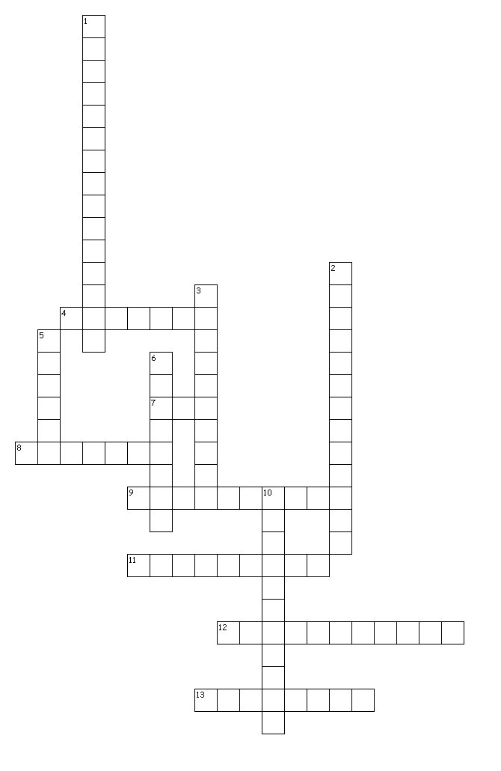
Across
4. Reflection that occurs when parallel rays of light hit a bumpy or uneven surface.
7. The source of all energy on earth.
8. Reflection the occurs when parallel rays of light hit a smooth surface.
9. When light bounces off of a surface.
11. Wave property the is related to energy.
12. Materials that scatters light as it passes through.
13. When light goes through an object.

Down
1. Wave that does not require matter.
2. Light wave represented as ____.
3. Type of wave that requires matter.
5. A material that reflects or absorbs all of the light that strikes it.
6. When light takes in an object.
10. Any object that transmits light

