Gobstoppers
(source: Doing Good Science, pg. 88)

Problems

- “Does the color of a Gobstopper change?”
- “How does the color change?”
- “How quickly does the color change?”
- “Does the color change more than once?”

Materials

- Four different-colored Gobstoppers
- Bowl
- Measuring cup
- Colored pencils
- Stopwatch

Procedures

1. Fill your bowl with 100 mL of water.

2. Gently place four different-colored Gobstoppers into the water, placing them around the edges, as far away from the others as possible. Use the clock diagram below to help you place the Gobstoppers. DO NOT DISTURB THE CUP OF WATER.
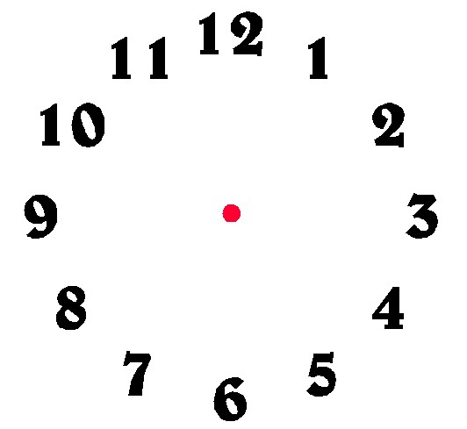

3. As soon as you place the Gobstoppers into the water, begin making observations. Write down everything you observe. Do this for twenty (20) minutes.

4. Make at least two drawings as the reaction takes place.

5. Complete the worksheet.
topper

Gobstoppers Data Sheet

1. Record what happens to the Gobstoppers over twenty (20) minutes.

___________________________________________________________________

___________________________________________________________________

___________________________________________________________________

___________________________________________________________________

2. Draw your two diagrams in the boxes below.

3. Describe what happened to the water over the twenty (20) minutes.

___________________________________________________________________

___________________________________________________________________

___________________________________________________________________
4. Describe the patterns of change in the water.

___________________________________________________________________

___________________________________________________________________

___________________________________________________________________

5. Describe the patterns of change in the Gobstopper.

___________________________________________________________________

___________________________________________________________________

___________________________________________________________________

6. What did you observe to indicate that a Gobstopper is a mixture of different dyes and flavors?

___________________________________________________________________

___________________________________________________________________

___________________________________________________________________

