**Gravity: A Force of Attraction**

Name________________________ Grade _____

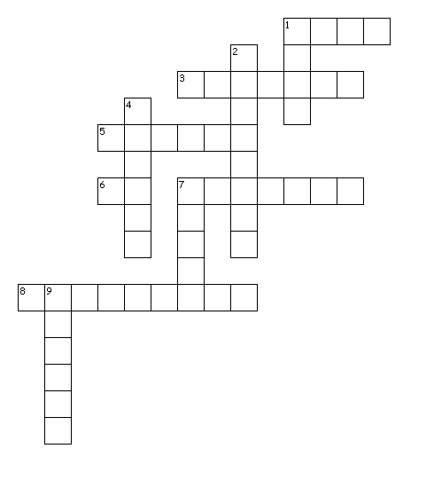

Across

1. The amount of matter in an object.

3. One newton equals one _________ grams.

5. Earth's gravity pulls all objects toward its ________.

6. The SI unit of mass.

7. Force of attraction between two objects that is due to their masses.

8. A law that applies to all objects in the universe.

Down

1. The more mass an object has, the ______ gravity it has.

2. If Earth's mass doubled your weight would increase/decrease.

4. The measure of gravity on an object.

7. Mass is measured in ____.

9. Who is responsible for creating the theory of gravity.