King Gong – Procedures

Question

What happens when you tap a metal hangar on a string and with cups for earpieces?

Vocabulary

- Medium – something that through which sound can travel.
- Vibration – rapid movement of something – air or some other object.

Materials

- Two plastic cups
- String
- Two paperclips
- Scissors
- Wire hanger
- Tape
- Object to tap hanger
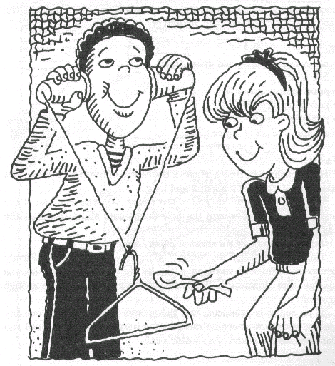
Procedure

1. Cut two segments of string, each about 2 feet long.

2. Pass one of the segments through the cup hole. Tie the end of this string segment that exits the inner side of the cup to a paper clip.

3. Repeat this process with the second cup.

4. Tie the free end of both strings to the hood of a metal hanger.

5. Place each cup over your outer ear. Let the hanger hang freely. Have a classmate tap on the hanger.

6. Go around and bump your hanger against other objects.

7. Repeat steps 5 & 6 without the cups over your ears.

8. Repeat steps 5 & 6 with an index finger in your ear.

9. Record your results on the worksheet.

Names _______________________________________________________________________

_____________________________________________________________________________

Absent _______________________________________________________________________

King Gong

Prediction

Record what you think will happen when you tap the hangar.

_____________________________________________________________________________

_____________________________________________________________________________

Observation and Analysis

1. How loud was the sound?

_____________________________________________________________________________

_____________________________________________________________________________

2. What principal of sound does this activity demonstrate?

_____________________________________________________________________________

3. What did you learn about sound in this activity?

_____________________________________________________________________________

_____________________________________________________________________________

