Name___________________ Grade ____

Marble Ramp

Purposes:
1) To practice working as a group
2) To practice problem-solving skills

Materials:
1 sheet of newspaper
1 meter masking tape
1 marble
Scissors
Meter stick

Procedure:
1. Using only the newspaper and masking tape, build a ramp that will:
a. Is at least 25 cm in height.
b. Will carry a marble the entire length of the ramp without being touched after it is first released.
c. Will cause the marble to change direction at least once.
d. Will stop the marble at the end of the ramp.
2. Do not use the scissors or meter stick as part of the ramp.
3. You will not receive extra paper or tape, once you use it up; it’s gone!
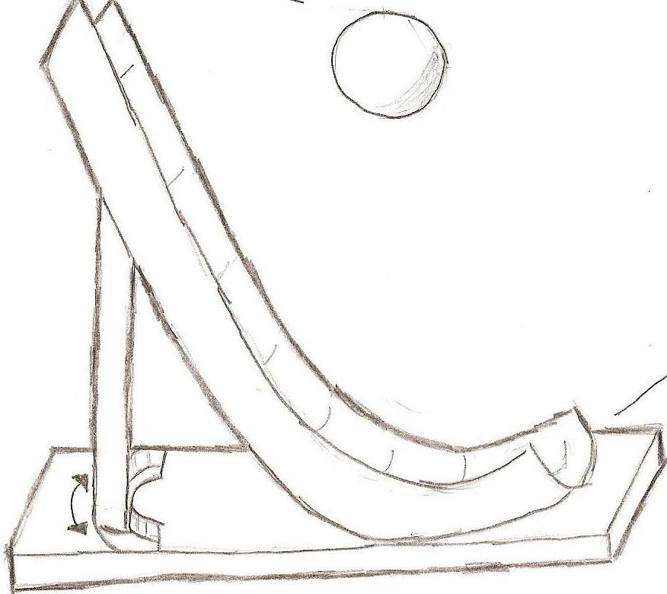

Conclusions:

1. How did working in a group make this activity easier to accomplish than working
alone?
__________________________________________________________________________________________________________
_____________________________________________________

2. How did working in a group make this activity harder to accomplish than working alone?
__________________________________________________________________________________________________________

3. List 5 things YOU can do make group work productive:
a.____________________________________________________b.___________________________________________________ c.____________________________________________________d.___________________________________________________
e.____________________________________________________

