Matter X - Word
Name ______________________________ Grade ______

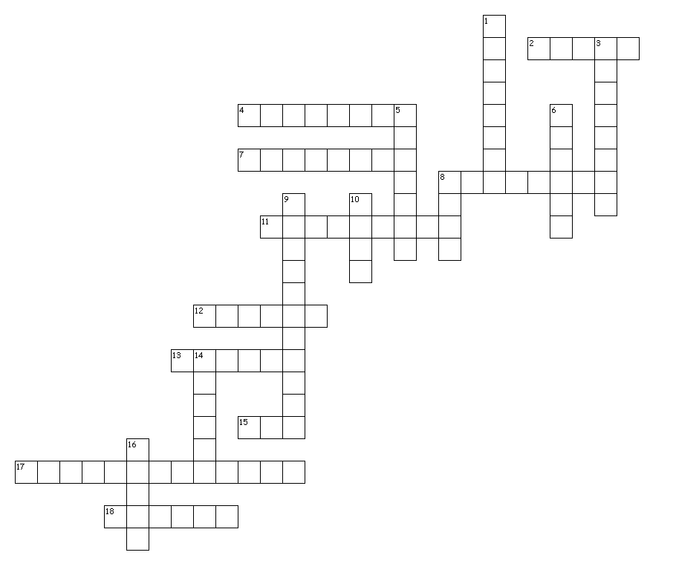

Across
2. The building blocks of Matter.
4. Consist of one type of atom. Cannot be broken down into a simpler type of matter.
7. If a new substance is formed it is this type of change.
8. Two or more atoms of the same element, or different elements, that are chemically bound together.
11. Atoms of two or more different elements bound together.
12. Anything that has a mass and a volume.
13. The substance to be dissolved.
15. State of matter which is very excited.
17. Mixture not uniformly mixed.
18. State of matter in which atoms slide past each other.

Down
1. Changing from one state to another is this type of change.
3. Substances held together by physical forces, not chemical.
5. The substance doing the dissolving.
6. How much space an object takes up.
8. How much volume is in an object.
9. Mixture that has uniform distribution.
10. How many states of matter there are (including plasma).
14. (H20) is a compound made of Hydrogen and ______________.
16. State of matter in which molecules vibrate.

