**Mineral ID X- Word**

Name_________________________ Grade ____

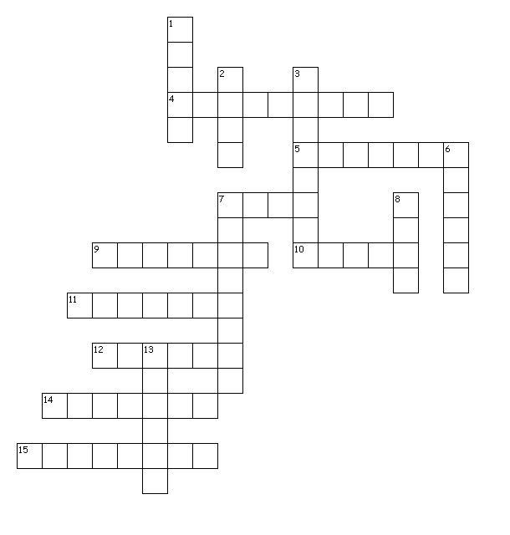

Down

1. Not Liquid or Gas or Plasma.

2. Scale used to measure hardness.

3. The resistance to being scratched.

6. The color of gold's streak.

7. The tendency of a mineral to break into irregular pieces.

8. The color of Galena's streak.

13. The color of the powder of a mineral

Across

4. - Not alive and never alive.

5. Mass of a given space.

7. Number of mineral characteristics.

9. The building blocks of rocks.

10. Slogan for the 5 mineral

characteristics.

11. A substance such as iron, oxygen,

and gold which cannot be separated or

broken down by ordinary chemical methods.

12. The way in which light reflects from the surface.

14. Not artificial or man-made.

15. Minerals with flat surfaces in an

orderly arrangement.