Party Line

Materials

- Three paper cups
- String
- Three paper clips
- Scissors

Procedure

1. Cut a segment of string about 4-5 feet long.

2. Pass one end of the string through the bottom hole of one cap. Tie the paper clip to the end of the string that projects from the inner side of the cup. Pull on the string so that the paper clip lies flat against the inside of the bottom of the cup.

3. Repeat Step 3 with the other cup.
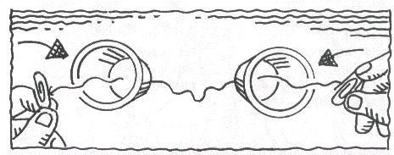
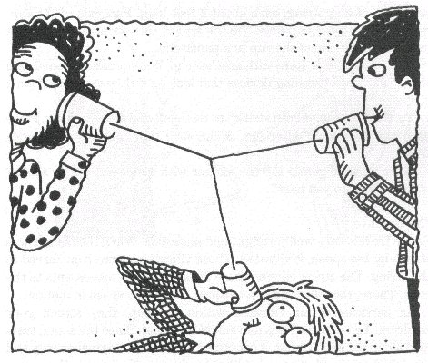
4. With a classmate, move the two cups apart so that the line between them is pulled taught. Try to talk to each other through the cups.

5. Cut a 2-3-foot segment of string.

6. Place a cup and paper clip at one end of the line.

7. Tie the free end to the middle of the two-cup line.

8. With three classmates, try to talk into the cups.

Group Members _______________________________________________________________

_____________________________________________________________________________

Absent _______________________________________________________________________

Party Line

Analysis and Questions

1. Describe what you hear when there are two “phones.”

_____________________________________________________________________________

_____________________________________________________________________________

_____________________________________________________________________________

2. Describe what you hear when there are three “phones.”

_____________________________________________________________________________

_____________________________________________________________________________

_____________________________________________________________________________

3. What causes the sound you hear?

_____________________________________________________________________________

