Plucker Up

Problem

- What happens when you pluck a string at different lengths?

Variable

- Length of string.

Vocabulary

- Medium – something that through which sound can travel.
- Pitch – sound that varies in tone (high or low).
- Vibration – rapid movement of something – air or some other object.

Materials

- String
- Cup
- Paper clip
- Scissors

Procedure

1. Cut a 12” segment of string.

2. Position the string between thumb and index fingers of both hands. Pull your hands apart so that the string is tight. (This may take some practice.)
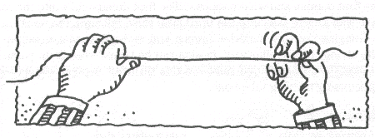

3. Pass the string through the hole so that it is positioned halfway through the cup.

4. Tie a paper clip to the string’s end that extends from the inside of the cup.
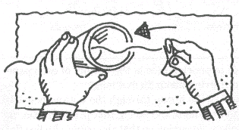
5. Pull back on the other end of the string so that the paper clip is pulled against the inner surface of the cup bottom.
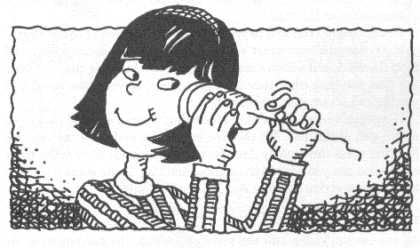
6. Cover your ear with the opening of the cup. Pull on the string so that it is taut.

7. Pluck the string. Change the length of the string. Answer the questions on the worksheet.

Group Members _______________________________________________________________

____________________________________________________________________________

Absent ______________________________________________________________________

Plucker Up

Complete this section before you begin.

Hypothesis

____________________________________________________________________________

____________________________________________________________________________

Complete this section while you do the experiment.

1. Describe the sound you hear.

____________________________________________________________________________

____________________________________________________________________________

2. Change the length of the string. Describe how the sound changes as you change the length.

____________________________________________________________________________

____________________________________________________________________________

Complete this section after you do the experiment.

1. Describe the results of this lab and what they mean.

____________________________________________________________________________

____________________________________________________________________________

____________________________________________________________________________

____________________________________________________________________________
2. After analyzing your results, was your hypothesis correct or incorrect? Explain why.

____________________________________________________________________________

____________________________________________________________________________

____________________________________________________________________________

____________________________________________________________________________

