Name ___________________ Grade ____

12

Sedimentary Rocks X Word
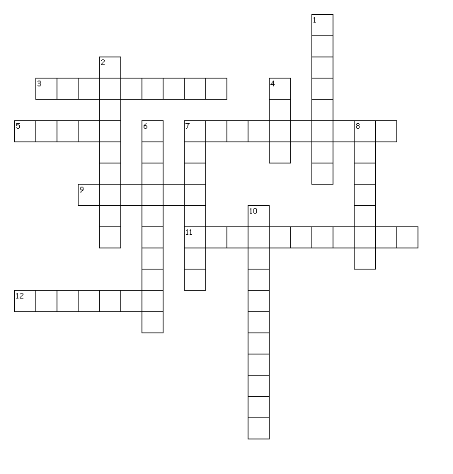
Across
3. Loose materials such as rock fragments, mineral grains, and bits of shell that have been moved by wind, water, ice, or gravity.
5. How many ways are sedimentary rocks classified.
7. If sediments have small pieces, this happens.
9. The oldest layers of sedimentary rocks will be found here.
11. If sediments have large pieces, this happens.
12. The moving of sediments.
Down
1. Broken fragments of other rocks.
2. A type of chemical sedimentary rock.
4. A type of organic sedimentary rock.
6. The breaking down of rocks.
7. Dissolved minerals come out of solution.
8. Made of the remains of once living things.
10. This rock forms when sediments are pressed and cemented together, or when minerals form from solutions.

