Name ____________________________ Grade ____

The Eye X-Word
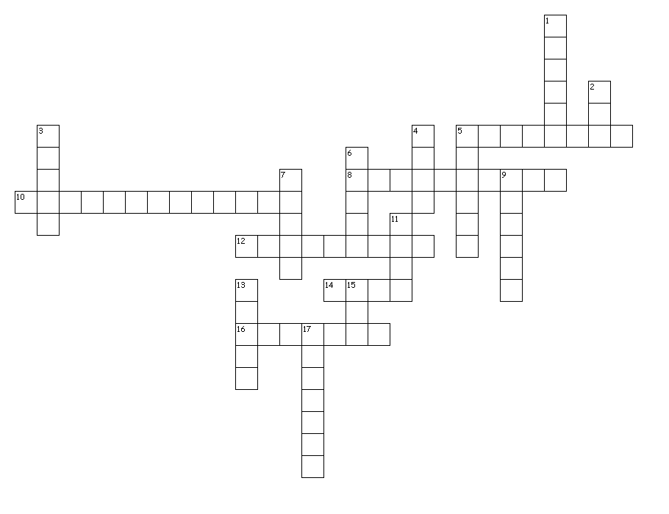
Across
5. One of two that helps correct our vision impairment.
8. Sends an electrical impulse to the brain transmitting the image to the brain.
10. The fluid inside the eye that gives the eye its shape.
12. A spot in each eye where we cannot take information or ‘See.’
14. Behind the pupil lens that perfects the image by refracting the light.
16. One of two that helps correct our vision impairment.

Down
1. Transparent front surface of the eye.
2. This cushions the eye so we don't get black eyes every time we hit a speed bump.
3. A HOLE! That lets light in.
4. Colored muscular structure that contracts and expands to control the amount of light that enters the eye.
5. The shape of the lens in a human eye.
6. These cells see color in three different bands.
7. One thing we need in order to see.
9. Layer of cells along the inside lining of the eye.
11. These cells see dim or bright light, only black and white.
13. Without _________ there would be no sight!!!
15. One thing we need in order to see.
17. The white part of the eye.

