The Magic School Bus Gets Charged
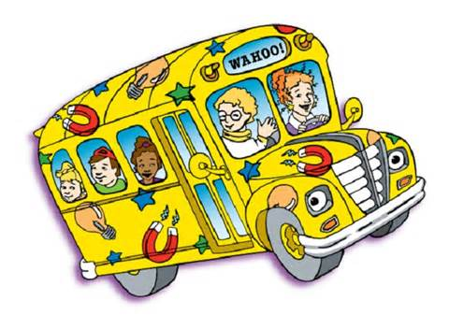

Word Bank
Bed Ballon Battery Broken Circuit
Current Filament Flow Opposite Good
Metal Opposite Power Switch Wires

1. Rubbing a _____________ on your head causes your hair to stick out.
2. The doorbell gets electricity from a _______________.
3. Charges that are the same stay together / separate.
4. A spark occurs when ______________ charges come together.
5. An electric _____________ is a constant flow of electrical charges.
6. The skinny wire inside a light bulb is called a ______________.
7. The circular path of electricity is called an electrical ____________.
8. Electricity will not flow if the circuit path is _______________.
9. A ____________ must be in the on position to allow electricity to flow.
10. The doorbell isn’t working because the __________ of charges was stopped..
11. Electricity travels through _____________ to the battery.
12. When checking for electrical problems, always turn the switch ____________.
13. Tin foil is a type of ______________ that will conduct electricity.
14. A bad / good battery will also cause a break in a circuit preventing the flow of charges.
15. Electricity for our houses comes from a _______________ plant.

