Name: ______________________________________ Hour: _____

*Building a Graph on Water Usage (Due: ________)

***This activity will be turned in. It must be completed on graph paper. No other paper will be accepted!***

Use the following table on U.S. water usage to build a BAR graph. This assignment will only be accepted on a sheet of graph paper and in pencil only. (You may color the bars if you like, but it is not required.) USE A RULER!!! (Refer to page 174 of your text if you need additional help in building your bar graph.)

U.S. Estimated Water Use in 1990
Water Use | Millions of Gallons per Day | Percentage of Total Water Use
Homes and Businesses | 39,100 | 11.5%
Industry and Mining | 27,800 | 8.2
Farms and Ranches | 141,000 | 41.5
Production of Electricity | 131,800 | 38.6

***For 4 extra credit points, use this same data to build a pie (circle) graph. The amount of points you receive will be based on how correct your pie graph is. (Refer to page 174 for help in constructing a pie (circle) graph.

 | Proficient……………Nearing Proficient…………….Needs Improvement…………………..…Little / No Effort
Correct Axes | 4 | 3.5 | 3 | 2.5 | 2 | 1.5 | 1 | .5 | 0
Units Correct for Graph | 4 | 3.5 | 3 | 2.5 | 2 | 1.5 | 1 | .5 | 0
Labels and Title | 4 | 3.5 | 3 | 2.5 | 2 | 1.5 | 1 | .5 | 0
Neatness | 4 | 3.5 | 3 | 2.5 | 2 | 1.5 | 1 | .5 | 0
Extra Credit Pie Graph (if Attempted)
 | Proficient……………Nearing Proficient…………….Needs Improvement…………………..…Little / No Effort
Construction of Pie Graph | 4 | 3.5 | 3 | 2.5 | 2 | 1.5 | 1 | .5 | 0
Total Points: _______________ out of 16

*What’s All the Hubbub, Bub? (Due: ________)
***Complete this activity in your Science Journal, on the next page of the Activities Section.***
You may have heard that several parts of our country (California and Georgia in particular) often have to conserve water. Doesn’t it seem like we have a heck of a lot of it? I mean, have you seen the ocean? It’s huge! So, what’s the issue here? Take a look at the following graphic and use it to answer a couple of questions.
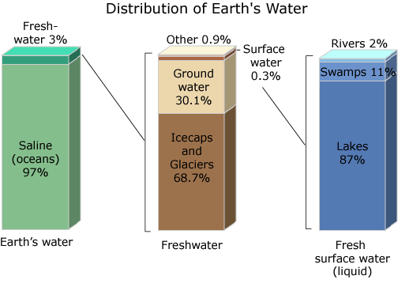
Note: The “Other” in the middle column represents the water in the atmosphere and contained in every living creature on the surface of our planet.
1. The first column represents all of the water on Earth. How much of all of the water on Earth can easily be consumed by humans?
________________________________________________________________________________________________________________________________________________________________________________________________________________________
2. The second column represents just the freshwater from the first column. Which of these do you think are easily
accessible by people? (Hint: Think of where we live on our planet.)
____________________________________________________________________________________________________________________________________________________________________________________________________
3. The third column represents the most commonly used freshwater sources to obtain drinking water. Are you surprised
by this information? Why or why not?
______________________________________________________________________________________________________________________________________________________________________________________________________________________________________________________________________________________________________
4. According to this data, nearly all of the water we use comes from about .04% of all of the water on Earth. Now, why is
the conservation of water pretty important?
________________________________________________________________________________________________________________________________________________________________________________________________________________________________________________________________________________________________________________________________________________________________________________________________________

Scoring
 | Proficient……………Nearing Proficient…………….Needs Improvement…………………..…Little / No Effort
Understands Usable Water Sources | 4 | 3.5 | 3 | 2.5 | 2 | 1.5 | 1 | .5 | 0
Interprets Accessible Water Sources | 4 | 3.5 | 3 | 2.5 | 2 | 1.5 | 1 | .5 | 0
Can explain understanding of freshwater amounts | 4 | 3.5 | 3 | 2.5 | 2 | 1.5 | 1 | .5 | 0
Applies Water Amounts to Water Conservation | 4 | 3.5 | 3 | 2.5 | 2 | 1.5 | 1 | .5 | 0

Total Points: _________ out of 16

