Name: _______________________________________ Hour: ______

It All Starts With (Fresh) Water
On this worksheet, you will find two tables. The first shows you how water is distributed (between freshwater and saltwater) on the entire planet. You are to use the table on this side to build a correct graph that shows the “Percent of Total Water” by “Water Source”. Once you receive your new textbook, use page 174 to help in your graph’s construction.

Water source | Water volume, in cubic miles | Water volume, in cubic kilometers | Percent of fresh water | Percent of total water
Oceans, Seas, & Bays | 321,000,000 | 1,338,000,000 | -- | 96.5
Ice caps, Glaciers, & Permanent Snow | 5,773,000 | 24,064,000 | 68.7 | 1.74
Groundwater | 5,614,000 | 23,400,000 | -- | 1.7
Soil Moisture | 3,959 | 16,500 | 0.05 | 0.001
Ground Ice & Permafrost | 71,970 | 300,000 | 0.86 | 0.022
Lakes | 42,320 | 176,400 | -- | 0.013
Atmosphere | 3,095 | 12,900 | 0.04 | 0.001
Swamp Water | 2,752 | 11,470 | 0.03 | 0.0008
Rivers | 509 | 2,120 | 0.006 | 0.0002
Biological Water (Yes, the water inside you.) | 269 | 1,120 | 0.003 | 0.0001
Total | 332,500,000 | 1,386,000,000 | - | 100
For this part, you will be reading a circle graph showing the average water usage of the United States by “How Water Is Used” and answering a few questions regarding water usage.
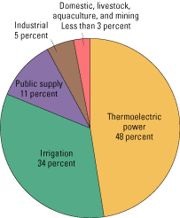
NOTES
- Thermoelectric is water
heated to make electricity.
- Public Supply includes
restaurants, hotels, water
fountains, etc.
- Domestic is your in-home
water.

1. Which of the categories shown represents the largest percentage of water used in the U.S.?
__________________________________________________________________________________________________

2. On an average day, you would most often use the “Domestic” supply and the “Public” supply. What is the total
percentage of water that you access each day? __________________________________________________________

3. Why do you think “Domestic, livestock, aquaculture and mining” were all grouped together instead of using separate
parts? ___________________________________________________________________________________________
__________________________________________________________________________________________________

For this part, you will be reading a circle graph showing the average water usage of different applications within your home and answering a few questions regarding water usage.
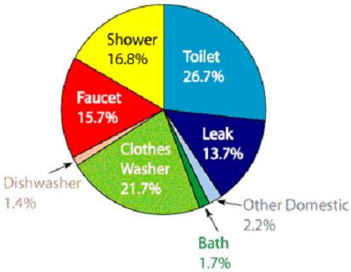
4. On average, what is the percentage of water you could save by taking a bath instead of a shower? ________________

5. If the average home uses 100 gallons per day, how much water is used for “bathroom purposes” (includes faucets)?
__________________________________________________________________________________________________

6. A high efficiency clothes washer uses only 80% of water a regular clothes washer would use. Based on a 100 gallon per day home, how many gallons would a high efficiency washer use? (Yes it’s math, get over it!)
__________________________________________________________________________________________________

