Name ________________________ Grade ___________
Weather Patterns X-Word
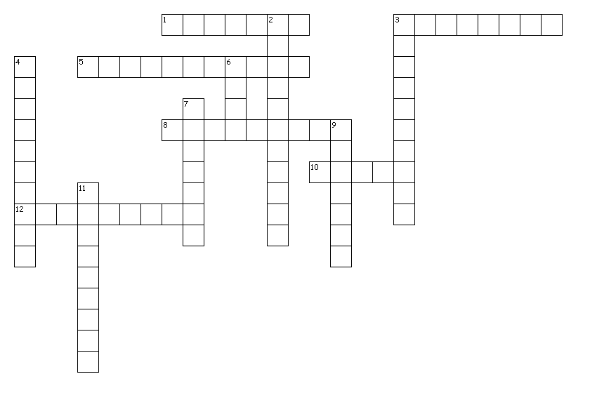

Across
1. The pattern of weather an area experiences over a long time.
3. The amount of water vapor in the air.
5. Warm fronts are represented by this shape.
8. This is one of the tool that is used to measure wind speed.
10. The border where two air masses meet.
12. Cold fronts are represented by this shape.

Down
2. This is the tool that is used to measure air temperature.
3. This is the tool that is used to measure humidity.
4. This is the tool that is used to measure wind speed.
6. Cold air mass or warm air mass, which is more dense?
7. A large body of air that has the same temperature and humidity throughout.
9. This type of cloud forms when a warm front advances over a cold air mass.
11. This is the tool that is used to measure air pressure.

