Name __________________ Date ____

X-Word # 2
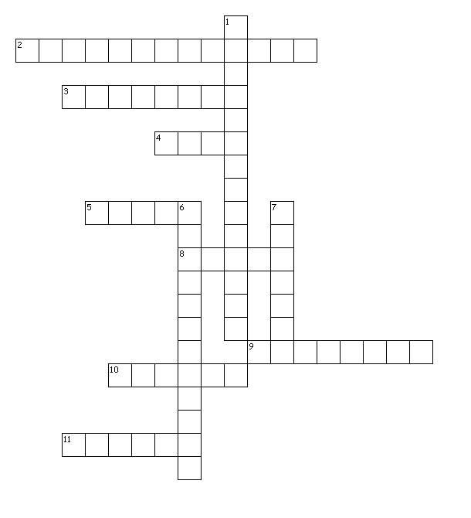

Across
2. Rate at which an object is moving at a given instant in time.
3. This variable always goes on the Y axis.
4. This variable always goes on the X axis.
5. Distance/time.
8. The steepness of line.
9. Speed with direction.
10. SI unit for distance.
11. An object that is changing its distance from another object.

Down
1. A place or object used for comparison to determine if something is in motion.
6. The shortest distance from the initial to the final position of a point.
7. Type of speed which is the total distance divided by total time.

